34.20: 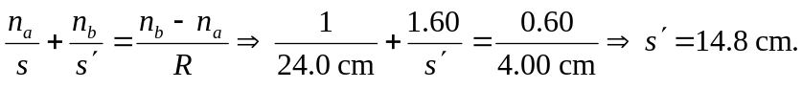
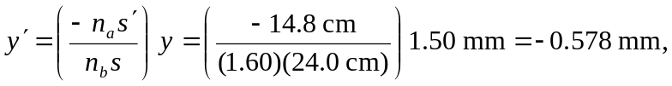so the image height is 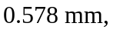and is inverted.

